**ITSC 309 - Social Engineering**

Assignment 1 - Organization Charts

D’Artagnan Boocock, Jack Chen, Coleton Sanheim

2022 - 05 - 28

**Mozilla Corporation Organization Chart**

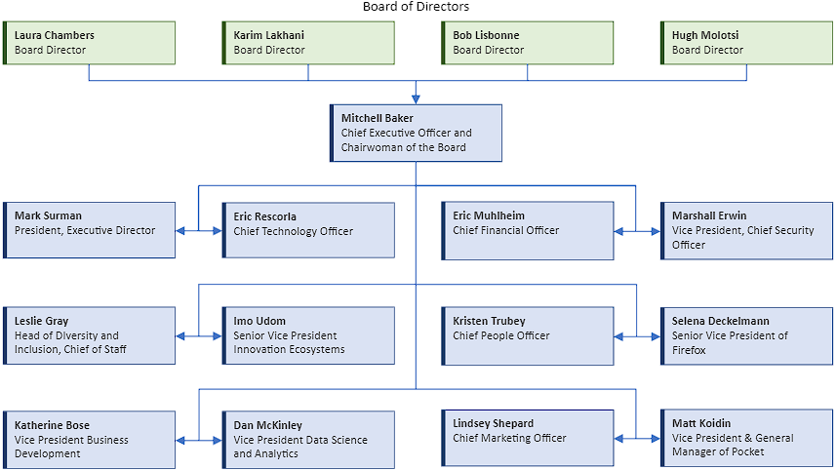

**Key Positions Within Company:**

**Mitchell Baker**, Chief Executive Officer, Chairwoman of Mozilla Foundation

Responsibilities: organizing and motivating the employees and volunteers of the company, managing the direction of the company for the main Firefox browser product, while discovering and investing in innovative solutions.

Board Members:

* **Laura Chambers**, Board Director of Mozilla Corporation
* **Karim Lakhani**, Board Director of Mozilla Corporation
* **Bob Lisbonne**, Board Director of Mozilla Corporation
* **Hugh Molotsi**, Board Director of Mozilla Corporation

Responsibilities: Governs over the whole company, ensuring that the company goals are met.

**Mark Surman**, President, Executive Director

Responsibilities: develops Mozilla’s annual Internet Health Report, decides the direction of the company and ensures the company is following their mission statement.

**Eric Rescorla**, Chief Technology Officer

Responsibilities: sets the long-term technical strategy for the company. He also works with the Engineering and Product departments to set the short-term technical direction.

**Eric Muhlheim**, Chief Financial Officer

Responsibilities: leads the financial operations for the company. Sets the budget for the company and ensures that the company stays within it.

**Lindsey Shepard**, Chief Marketing Officer

Responsibilities: leads the company’s global marketing strategy to attract new customers. Oversees product launches and ensures the company is represented by their brand.

**Marshall Erwin**, Vice President and Chief Security Officer

Responsibilities: leads the team responsible for protecting Mozilla and its users, responding to cybersecurity attacks and ensuring the company builds secure products. He is in charge of ensuring the company is adhering with cybersecurity policy.

**Imo Udom**, Senior Vice President, Innovation Ecosystems

Responsibilities: discovering and developing new innovative ideas and technology outside the company’s core products.

**Kristen Trubey**, Chief People Officer

Responsibilities: leads the HR and Organizational departments at the company, which includes Recruiting, Total Rewards, Learning and Development, Culture and Engagement, Client support, Workplace Resources and People Operations.

**Leslie Gray**, Head of Diversity and inclusion, Chief of Staff

Responsibilities: responsible for the company’s global inclusion strategy and programs across the company, responsible for managing business operations for the Office of the CEO.

**Dan McKinley**, Vice President, Data Science and Analytics

Responsibilities: leads the company’s data engineering, data science, and machine learning departments. Leads engineering operations, IT, Mozilla Rally, and Kaala.

**Matt Koidin**, Vice President and General Manager, Pocket

Responsibilities: responsible for the Pocket platform

**Katherine Bose**, Vice President of Business Development

Responsibilities: leads the growth and partnerships departments. responsible for managing product partnerships, generating new revenue streams and exploring new business models and opportunities.

**Selena Deckelmann**, Senior Vice President, Firefox

Responsibilities: responsible for implementation of the Web Platform (the Gecko browser engine), and the growth and development of the Firefox desktop and mobile products.

**Mozilla Corporation Data Flow Diagram**

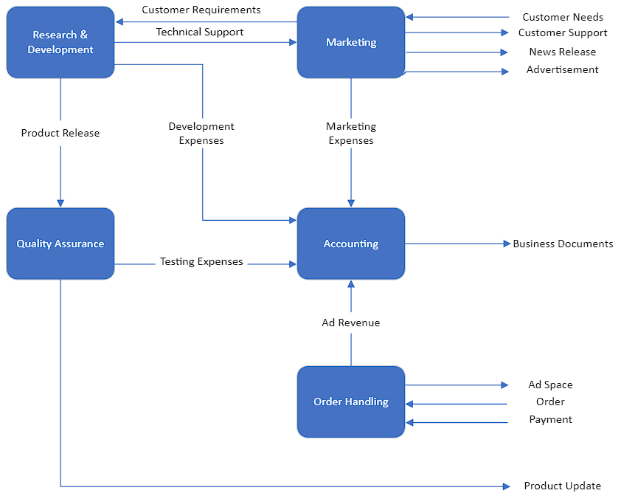

**Research and Development**  
The research and development department will share technical support information with the marketing department and information about new releases with the quality assurance department.

**Marketing**  
The marketing department is responsible for releasing information about the changes to the organization’s product lineup and creating the advertisements for those products. They also receive the information that the end user provides so that it can be used by the research and development department for the next product update.

**Quality Assurance**  
The quality assurance department is responsible for receiving the information given by the research and development department and does quality checks on the product for vulnerabilities and bugs in the product before it is released to the end user.

**Accounting**  
The accounting department takes expense reports from the above departments and compiles tax returns.

**Order Handling**   
The order handling department is tasked with processing customer requests for ad space, calculating costs and then providing the ad space. This department also generates ad revenue which is passed on to accounting.